Types of backups:

Full or partial- back ups either the full database or a section of it and everything that relates.

|  |  |
| --- | --- |
| Pro | Con |
| Backups database to be used in recovery. | Could take forever to back up a database if it is busy |
| Able to recover from disaster | Hard to back up while other writes are being issued |
| Can be used to recover small sections that got deleted | Must find less busy times to implement |
| When planned can be easy to reimplement | Must remember to perform backups often. |

Everything or object definitions- full back up of database and its relations or just backing up the relations to the database to be applied later.

|  |  |
| --- | --- |
| Pro | Con |
| Restores logical aspects to the database | Need to back up physical part separately with object related. |
| Can restore the physical as well as logical. | Could take a while to back up everything. |
| Object can be used to recover relations that were lost from a backup. |  |

Point in time recovery- recovers to a specific point in time before changes were made, usually before a big update or a change.

|  |  |
| --- | --- |
| Pro | Con |
| Can restore to before a big update. | Loses all progress since that point in time. |
| Can restore performance. | Hard to implement. |
| Restores before a script or transaction ran on database. |  |
| Can restore lost sections of a database. |  |

Restore performance- back up includes restoring the database to a point in time before the performance was changed.

|  |  |
| --- | --- |
| Pro | Con |
| Can restore to point in time. | Loses all progress since the backup. |
| Restores performance before an update that caused issues. | Hard to implement. |
|  | Performance issues could still occur. |

Pg_dump to back up database:





Pg_dump schemas:





Pg_dumpall roles only:





Pg_dumpall tablespaces only:





Backing up database using PG Admin:

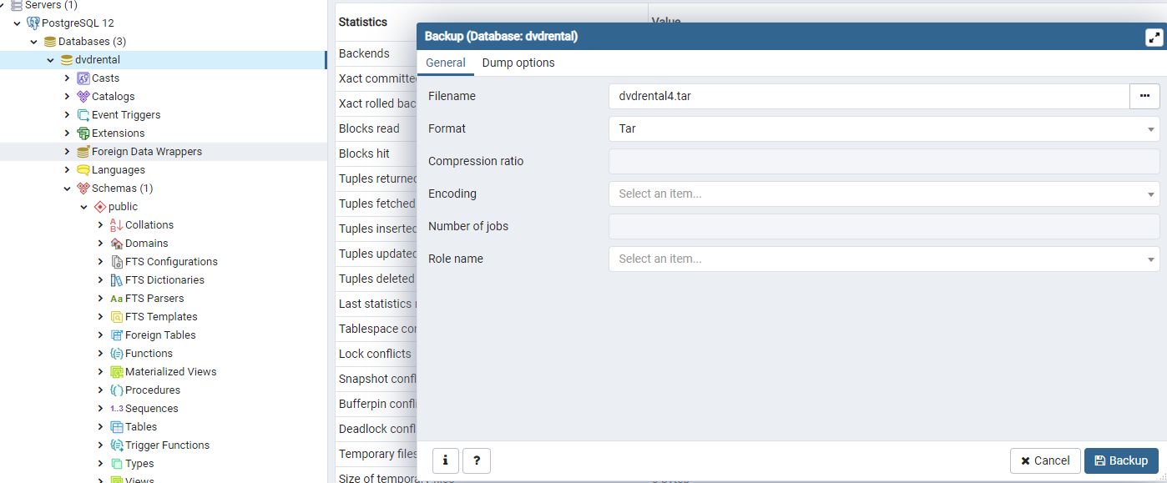

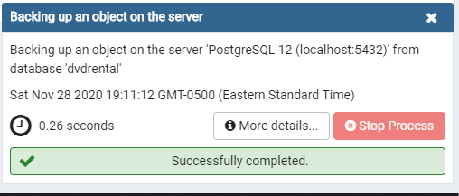



Only schema:

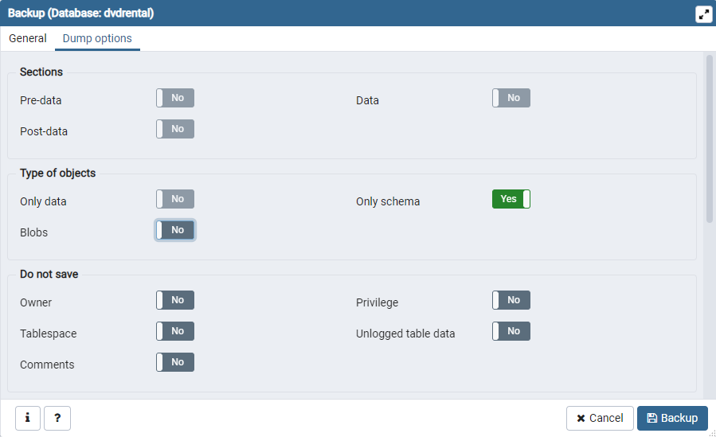



Tablespaces only:

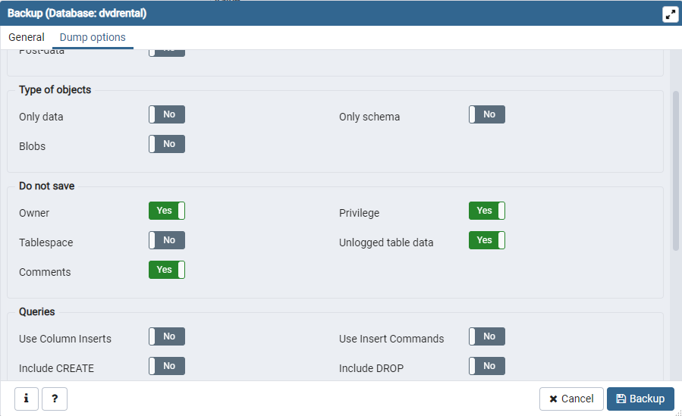



Roles only:

